SIMATS ENGINEERING

ASSESSMENT TOOL 1
COURSE NAME: Data Warehousing and Data Mining COURSE CODE: CSA16

COURSE OUTCOME COVERED
CO3: Evaluate the effectiveness of classification techniques on real-time data for accurate prediction, enabling informed decision-making. (BL3,BL4,BL5)
Assessment Tool Weightage: 50%

QUESTIONS: 5 Duration: N/A Total Marks: 50

Annexure A
Experiments

Code of Conduct:
I, LOHITH.S (Reg. No. 192471053), certify that this submission is my original work and that I have adhered to the guidelines specified for this assessment.
I understand that any violation of academic integrity rules will result in disciplinary action.

Signature of the student: LOHITH.S

Chi-Square Test: Age vs Photograph Preference (10 Marks)
Children of three ages indicate their preference for three photographs of adults. Do the data suggest a significant relationship between age and photograph preference? What is wrong with this study? Also use cov()/cor() to compute the sample covariance and correlation (matrices) for the preferences.

Age of Child | Photo A | Photo B | Photo C | Row Total
5-6 years | 18 | 22 | 20 | 60
7-8 years | 2 | 28 | 40 | 70
9-10 years | 20 | 10 | 40 | 70
Column Total | 40 | 60 | 100 | 200

Chi-Square Test of Independence
Expected frequency = (row total × column total) / grand total:

 | Photo A (E) | Photo B (E) | Photo C (E)
5-6 years | 12 | 18 | 30
7-8 years | 14 | 21 | 35
9-10 years | 14 | 21 | 35
² = (OE)²/E = 3.0+0.889+3.333+10.286+2.333+0.714+2.571+5.762+0.714 = ²  29.60, df =
(31)(31) = 4. Critical value at =0.05, df=4 is 9.488.
Conclusion: since ² (29.60) ■ critical value (9.488), we reject the null hypothesis of independence
— the data do suggest a statistically significant relationship between a child's age and their photograph preference.

What Is Wrong With This Study
- The photographs themselves are not described — without knowing what makes Photo A, B, and C different (attractiveness, familiarity, race/gender of the pictured adult, etc.), any “preference” pattern is uninterpretable; age could be confounded with an unmeasured photo attribute rather than genuinely reflecting a developmental preference.
- No information is given on how children were sampled (random vs. convenience sample) or how many children are in each age group individually, making it hard to judge whether the groups are comparable.
- Young children's self-reported preferences are notoriously unreliable and easily influenced by question phrasing, order of photo presentation, or experimenter cues — none of which the study describes controlling for.
- A significant chi-square result shows association, not causation — it cannot, by itself, explain why
preference shifts with age.

R-style Covariance and Correlation (cov() / cor())
Treating each photo's 3 age-group counts as a vector: B = (22, 28, 10), C = (20, 40, 40).
cov(B, C): mean(B)=20, mean(C)=33.33; deviations (2,8,10) × (13.33,6.67,6.67) sum to 40; sample covariance = 40/(31) = 20.0

cov() — full covariance matrix for (A, B, C):

 | A | B | C
A | 97.33 | 74.00 | 46.67
B | 74.00 | 84.00 | 20.00
C | 46.67 | 20.00 | 133.33
cor(B, C): 20.0 / (84 × 133.33) = 20.0/105.83  0.189
cor() — full correlation matrix for (A, B, C):

 | A | B | C
A | 1.000 | 0.818 | 0.410
B | 0.818 | 1.000 | 0.189
C | 0.410 | 0.189 | 1.000
Interpretation: preference for Photo A is strongly negatively correlated with preference for Photo B (0.818) across age groups — as one photo becomes more preferred with age, the other becomes less so, consistent with the raw counts showing very different age profiles for A vs. B.

Boxplot for Outlier Detection: Tennis Points (10 Marks)
The tennis coach wants to determine if any players are scoring outliers, and visualize the distribution of points scored using a boxplot.
Points (15 players), sorted: 10, 11, 12, 13, 14, 15, 16, 17, 18, 19, 20, 21, 22, 23, 35.
Median (8th of 15) = 17. Q1 (median of lower 7: 10–16) = 13. Q3 (median of upper 7: 18–35) = 21. IQR
= 2113 = 8.
Lower fence = Q1  1.5×IQR = 1312 = 1. Upper fence = Q3 + 1.5×IQR = 21+12 = 33.
Outlier detected: Player J (35 points) — exceeds the upper fence of 33.
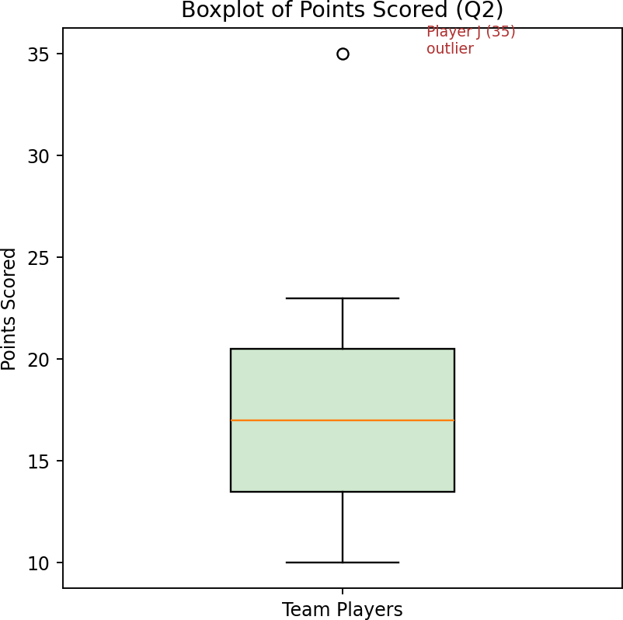
How the coach builds it: sort the scores, compute Q1/median/Q3 and the IQR, draw a box spanning Q1 to Q3 with a line at the median, extend whiskers to the most extreme values still within 1.5×IQR of the box (10 and 23 here), and plot any value beyond the fences as an individual point — flagging Player J's 35 as worth a closer look (an usually strong game, or possibly a scorekeeping error).

Decision Tree Classifier for Loan Approval (10 Marks)
Build a Decision Tree classifier to predict Loan Approval (Yes/No) from Age, Income, Employment Status, and Credit Score, using the given 15-record historical dataset.

Step 1: Root-Node Selection by Information Gain
Class distribution: 9 Yes, 6 No out of 15  Entropy(S) = (9/15)log■(9/15)  (6/15)log■(6/15)  0.971 bits.

Attribute | Information Gain
Age | 0.083
Income | 0.711
Employment Status | 0.470
Credit Score | 0.730  highest, selected as root
Splitting by Credit Score gives two immediately pure branches (good  all 5 Yes; poor  all 5 No) and one impure branch (average: 4 Yes, 1 No) that needs one further split. Within that branch, splitting by Age perfectly separates the remaining 5 records (youngYes, middleYes, oldNo), so the tree is fully resolved after two levels.
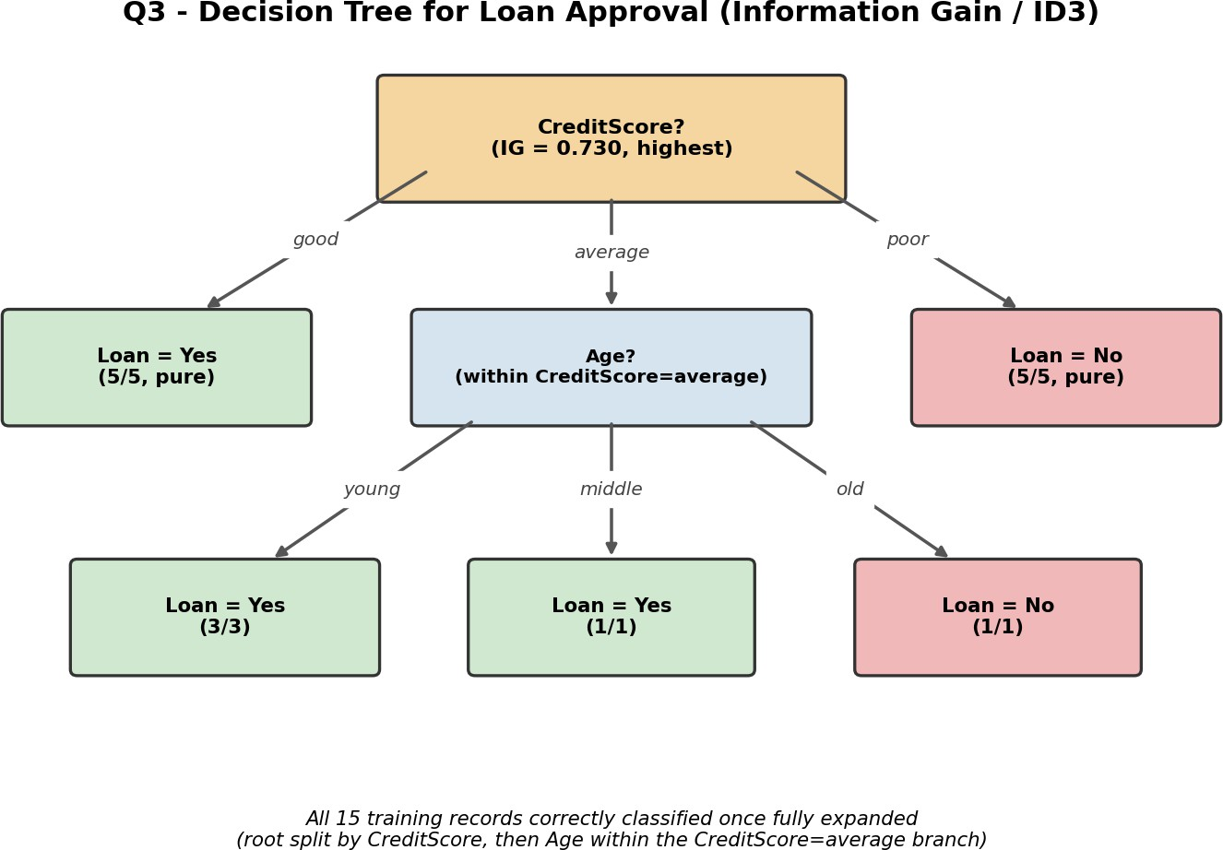

This tree correctly classifies all 15 training records: Credit Score is the strongest single predictor of loan approval in this dataset, and Age resolves the one remaining ambiguous group (average credit score).

Comparing Two Classes' Exam Performance (5 Marks)
Class A: 76, 35, 47, 64, 95, 66, 89, 36, 84. Class B: 51, 56, 84, 60, 59, 70, 63, 66, 50. (i) Which class
scored higher mean, median and range? (ii) Plot in a boxplot and give inferences.

Statistic | Class A | Class B
Mean | 65.78 | 62.11
Median | 66 | 60
Range | 9535 = 60 | 8450 = 34
Q1 / Q3 | 41.5 / 86.5 | 53.5 / 68.0
IQR | 45.0 | 14.5
  - Class A has the higher mean (65.78 vs 62.11), higher median (66 vs 60), and the wider range (60 vs 34).
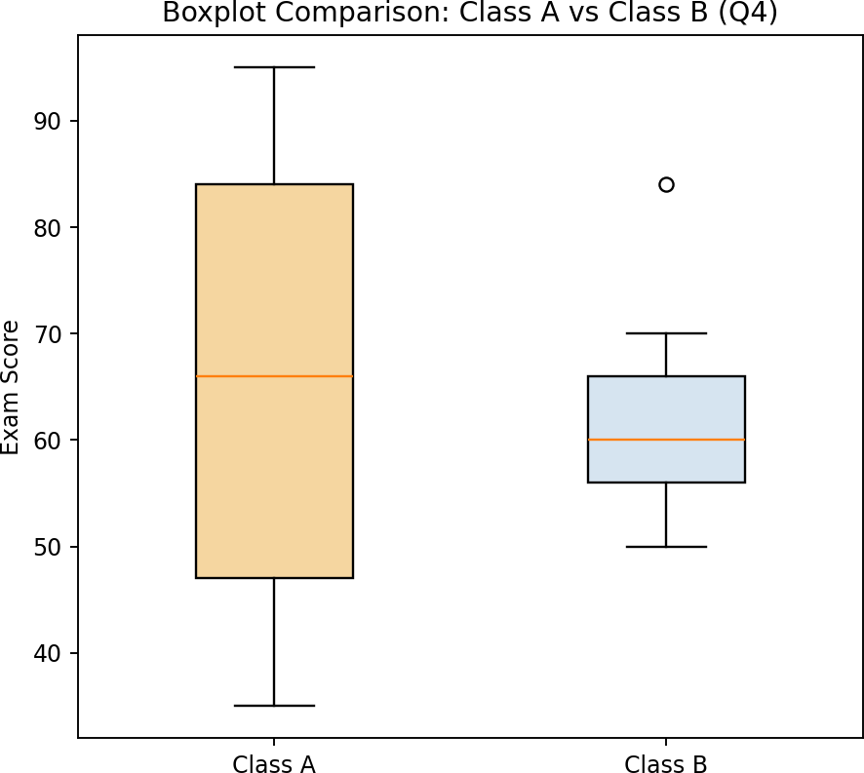
  - Inferences: although Class A scored higher on average, its much larger IQR (45 vs 14.5) and range show far greater spread/inconsistency — some students scored very low (35, 36) alongside others scoring very high (95, 89). Class B's scores are more tightly clustered around its median, indicating more consistent, moderate performance across the whole class, even though its average is slightly lower.

Age and Body Fat Analysis (10 Marks)
Age and %fat data for 18 randomly selected adults. (a) Compute mean, median, and standard deviation of age and %fat. (b) Draw boxplots. (c) Draw a scatter plot and a Q-Q plot.

age | 23 | 23 | 27 | 27 | 39 | 41 | 47 | 49 | 50
%fat | 9.5 | 26.5 | 7.8 | 17.8 | 31.4 | 25.9 | 27.4 | 27.2 | 31.2
age | 52 | 54 | 54 | 56 | 57 | 58 | 58 | 60 | 61
%fat | 34.6 | 42.5 | 28.8 | 33.4 | 30.2 | 34.1 | 32.9 | 41.2 | 35.7

Descriptive Statistics

Variable | Mean | Median | Std Dev (sample)
Age | 46.44 | 51.00 | 13.22
%Fat | 28.78 | 30.70 | 9.25

Boxplots
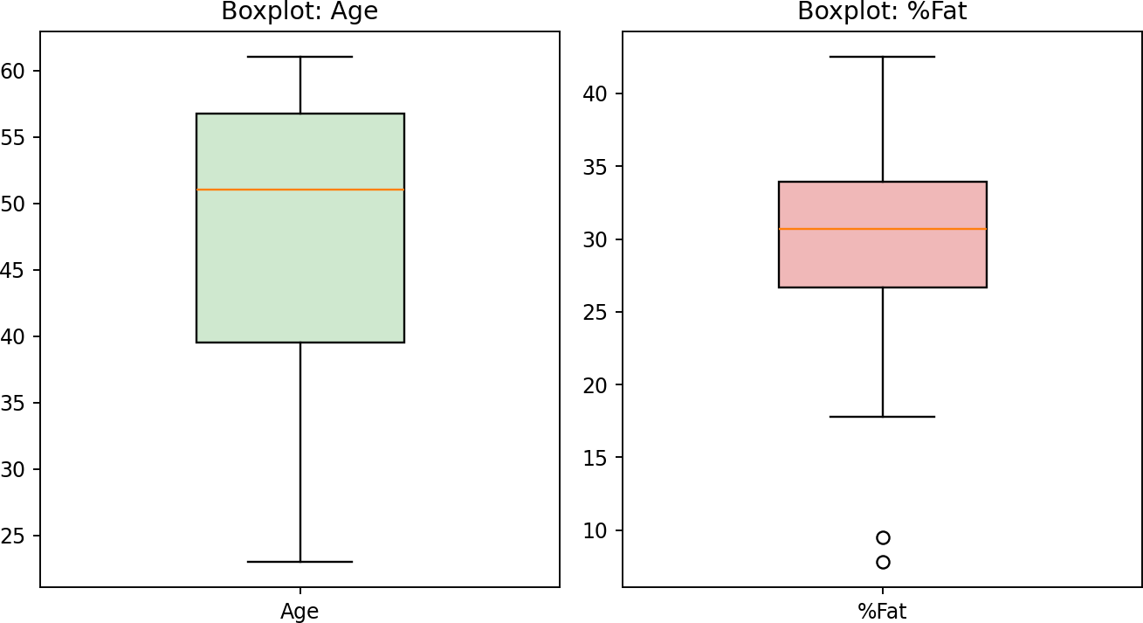

Scatter Plot and Q-Q Plot

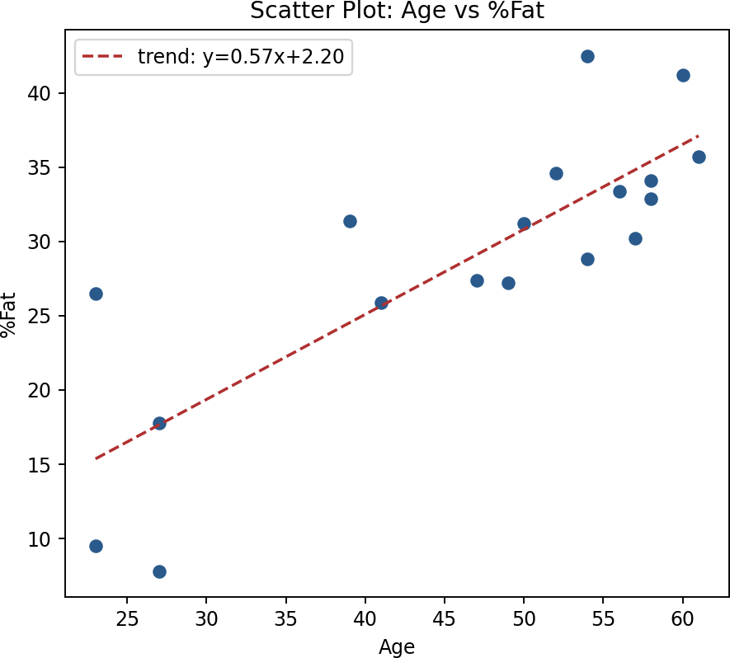
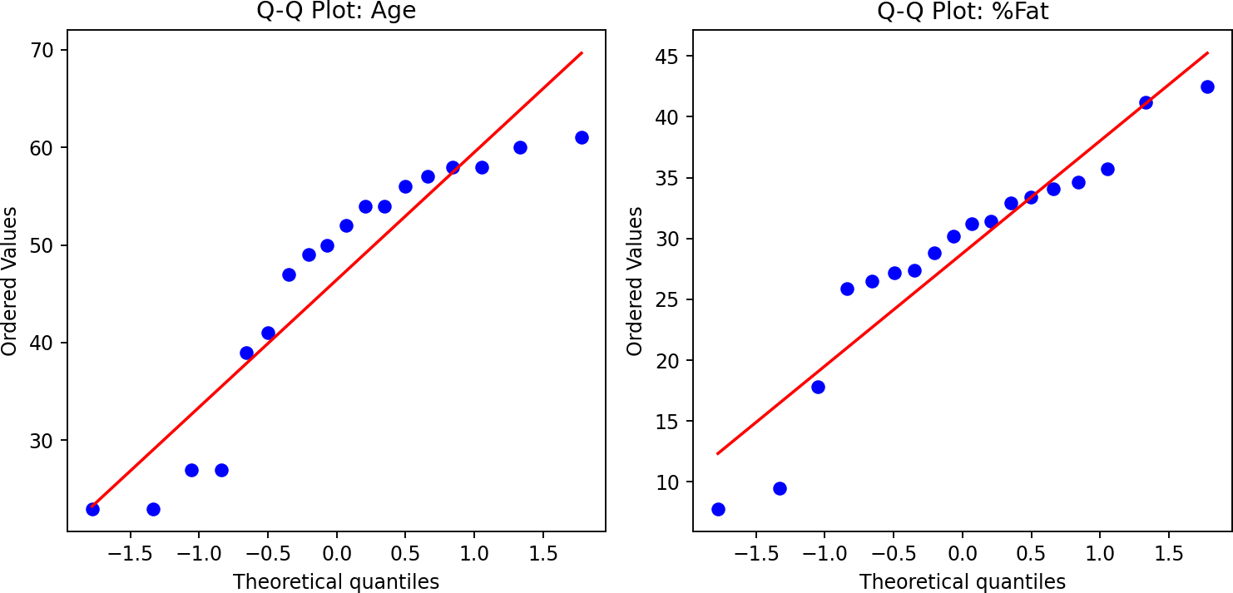
Interpretation: the scatter plot shows a clear positive linear relationship between age and body fat percentage (trend line slope  +0.57), consistent with the physiological expectation that body fat tends to increase with age. Both Q-Q plots show the data points following the reference line reasonably closely with only mild deviation at the tails, suggesting age and %fat are each approximately normally distributed across this sample, which supports using standard parametric statistics (as computed in part a) with reasonable confidence.

